A Cryogenic Technology Solutions Company

Scientific Instruments’ presence in the aerospace industry dates back to its birth in 1967 when founder Jack Hoey and Gilbert Halverson developed the first commercially available Germanium Resistance Thermometer (GRT) and supplied these devices for use on the Apollo Lunar Program.
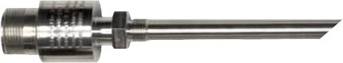
SI has a long history of providing quality products while remaining focused on customer satisfaction and support. Expanding on over 46 years of R&D and engineering expertise, SI brings innovation to multiple business areas including aerospace, defense, commercial aircraft, medical, research and industrial markets.

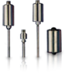
Scientific Instruments has supplied all of the ground support temperature and liquid level probes and transducers for the liquid Hydrogen and liquid Oxygen portion of the fuel system for the Shuttle vehicles. Other SI products have been used on the Hubble Telescope and Delta II missions.

With our highly trained and experienced staff we have the unique capability to custom design and fabricate products to meet expanding aerospace requirements.

We are a small, woman owned and operated business located in South Florida.

NAICS Codes: 334513, 334516, 334519, 336413
Scientific Instruments Inc. Phone: 1-800-466-6031
4400 W. Tiffany Dr. fax: 1-561-881-8556
West Palm Beach, FL 33407 www.scientificinstruments.com

